Alex Arnold
Professor Torres
4-10-25
IT 120-41198
Lab 10

Part A:
Research the below vulnerabilities/exploits and how to protect against them:
- Shellshock (2014)
  - Also known as Bashdoor is a family of bugs in the Unix Bash shell that can enable an attacker to execute arbitrary commands and gain unauthorized access.
  - CVE-2014-6271, CVE-2014-6277, CVE-2014-6278, CVE-2014-7169, CVE-2014-7186, CVE-2014-7187
  - To prevent this issue bash43-027+ should be used as these issues were patched in that version.
- Eternal Blue
  - a computer exploit software developed by the U.S. National Security Agency (NSA).[6] It is based on a vulnerability in Microsoft Windows that allowed users to gain access to any number of computers connected to a network. The NSA knew about this vulnerability but did not disclose it to Microsoft for several years, since they planned to use it as a defense mechanism against cyber attacks. This was then stolen by a group called Shadow Brokers at which point the NSA notified Microsoft and security updates were released in 2017
  - Eternal Blue exploits the implementation of the SMB protocol in Windows. Using specially crafted packets with SMB version 1 the protocol mishandles the packet allowing for remotely executed code to run on the target computer.
  - CVE-2017-0144
  - Installing the MS17-010+ patch will resolve the issue
- Heartbleed
  - a security bug in some outdated versions of the OpenSSL cryptography library, which is a widely used implementation of the Transport Layer Security (TLS) protocol. It was introduced into the software in 2012 and publicly disclosed in April 2014.
  - This vulnerability was classified as a buffer over-read this means that the attacker was allowed to read more data from the memory buffer then should be allowed.
  - CVE-2014-0160
  - Using OPENSSL version 1.0.1g + will resolve the vulnerability
- Apache Struts 2 Vulnerability
  - Apache Struts2 is an open-source web application framework used for developing Java web applications. Successful exploitation of this vulnerability could allow for remote code execution in the context of the affected service account. Depending on the privileges associated with the service account, an attacker could then install programs; view, change, or delete data; or create new accounts with full user rights.
  - CVE-2024-53677
  - Users are recommended to upgrade to version 6.4.0 at least and migrate to the new file upload mechanism. If you are not using an old file upload logic based on FileuploadInterceptor your application is safe.
- Apple iAmRoot
  - macOS High Sierra before Security Update 2017-001 is affected. The issue involves the "Directory Utility" component. It allows attackers to obtain administrator access without a password via certain interactions involving entry of the root user name.
  - CVE-2017-13872
  - Installing macOS High Sierra update 2017-001 or newer will resolve the issue
- POODLE Attack
  - POODLE is a vulnerability that leverages a weakness in how SSL 3.0 handles block cipher mode padding, allowing attackers to decrypt encrypted data.
  - CVE-2014-8730
  - Disable SSL 3.0 support on both servers and browsers.
  - Implement TLS 1.2 or higher for secure communication.
  - Enable TLS_FALLBACK_SCSV to prevent forced downgrades to SSL 3.0.
  - Keep software and systems updated with the latest security patches.
  - Use strong encryption algorithms and ciphers.
- Conficker
  - Aka: Downup, Downadup, and Kido
  - is a computer worm targeting Microsoft Windows operating systems, first detected in November 2008.
  - It uses flaws in Windows OS software (MS08-067 / CVE-2008-4250)[3][4] and dictionary attacks on administrator passwords to propagate while forming a botnet, and has been unusually difficult to counter because of its combined use of many advanced malware techniques.
  - CVE-2008-4250
  - The MS08-067 patch or newer is immune to the worm
  - Do not follow unsolicited links and do not open unsolicited email messages.
  - Use caution when visiting untrusted websites.
  - Use caution when downloading and installing applications.
  - Obtain software applications and updates directly from the vendor's website.
- Microsoft RPC DCOM
  - A vulnerability in Microsoft's Distributed Component Object Model (DCOM) interface, which utilizes Remote Procedure Call (RPC), allows attackers to execute code with Local System privileges on vulnerable systems by sending specially crafted RPC messages
  - CVE-2003-0352
  - Microsoft released a 3 phase update release to remediate the issue and address the vulnerability.
ensure configuration manager 2203 or later is running
  - Block port 135 on the firewall
- Golden Ticket Attack
  - A golden ticket attack is a post-exploitation technique in which a threat actor gains near-unrestricted access to an organization’s domain by forging authentication tickets within Microsoft Active Directory (AD). This attack exploits weaknesses in the Kerberos authentication protocol, allowing an adversary to maintain persistent access and move laterally within the network without normal authentication checks.
  - There is no single CVE that directly addresses golden ticket attacks but CVE-2021-42287 is a relevant vulnerability
  - To protect against Golden Ticket attacks, organizations should implement robust security measures, including patching vulnerabilities like CVE-2021-42287, monitoring Kerberos authentication activity, and implementing strong password policies for the KRBTGT account.
- Silver Ticket Attack
  - A silver ticket attack is a post-exploitation attack where an adversary forges a Kerberos service ticket (TGS) to access specific services without needing reauthentication by the domain controller. Unlike a golden ticket attack, which grants full domain control, a silver ticket attack is more targeted, allowing adversaries to abuse a specific service account while bypassing certain security controls.
  - There is no single CVE that directly addresses golden ticket attacks but CVE-2021-2020-17049 and CVE-2022-33679 are relevant vulnerabilites
  - Patch servers and images for CVE-2014-6324 (mentioned in Varonis article).
  - Implement Least Privilege principles and ensure service accounts are properly configured.
  - Enable Privileged Attribute Certificate (PAC) validation in Kerberos.
  - Monitor for suspicious ticket requests, especially those using RC4 encryption.
  - Auditing and monitoring service accounts are crucial.
  - Enforcing Kerberos Armoring (FAST) on clients and KDCs can also help.
- Pass-The-Hash
  - Pass the hash (PtH) is a type of cybersecurity attack in which an adversary steals a “hashed” user credential and uses it to create a new user session on the same network. Unlike other credential theft attacks, a pass the hash attack does not require the attacker to know or crack the password to gain access to the system. Rather, it uses a stored version of the password to initiate a new session.
  - Ther is no single CVE for this kind of attack as it is more of a method of attacking / a vulnerability type rather tan a specific one off exploit.
  - Mitigation are more the implementation of security principals / practices than a specific software patch.
    - Principal of least privilege implementation
    - Zero trust
    - Privileged Access Management
    - Identity segmentation
    - Threat detection and response
- Log4j
  - Aka Log4Shell
  - a critical remote code execution (RCE) vulnerability in the Apache Log4j Java logging library. It allows malicious actors to gain complete control of vulnerable devices and execute arbitrary code.
  - CVE-2021-44228
  - The primary mitigation is to upgrade Log4j to a patched version, such as 2.15.0 +

- How do you protect your company from Google hacking (there is no CVS/CWE or CVSS for this one)
  - Restrict information – avoid sharing sensitive data online and if you must then insure that the piles are not indexed by search engines
  - Implement a robust robots.txt file to ensure only the correct pages are crawled by search engines
  - Use noindex and nofollow tags which tell search engines which pages to index or not
  - Regularly audit your web facing content and servers.
  - Limit file and directory permissions
  - Use firewalls to limit what ports and services are openm to the internet
Part B:
Define the below terms and in simple terms, how they work. What major website maintains them (except for risk score)
- CVE
  - CVE is Common vulnerabilities and Exposures
  - IT is a public list of publicly disclosed vulnerabilities that are given a unique identifier. This then provides a standard method for identifying and communicating the details of these vulnerabilities.
  - This is maintained by the MITRE Coporation

- CWE
  - CWE is Common Weakness Enumeration
  - This is similar to CVE but it discusses weaknesses that can lead to vulnerabilities.
  - This is maintained by the MITRE Coporation
- CVSS
  - CVSS is Common Vulnerability Scoring System
  - This is a standardized framework that allows for the assessment of Vulnerabilities against a set of set metrics. This allows for the ranking of issues by severity and can help people to understand at a glance how major of an issue the vulnerability is.
- NIAC (original developers) selected the Forum of Incident Response and Security Teams (FIRST) to become the custodian (maintainers and developers) of CVSS.

- risk score (with respect to vulnerabilities)
  - a numerical representation of the potential harm a specific vulnerability could cause to an organization
- *find the CVE/CWE/CVSS for all of the above exploits -if you can*
  - Shellshock
    - CVE – CVE-2014-6271, CVE-2014-7169, CVE-2014-7186, CVE-2014-7187, CVE-2014-6277, CVE-2014-6278
    - CWE – CWE-78
    - CVSS - 9.8 score
      - Vector: CVSS:3.1/AV:N/AC:L/PR:N/UI:N/S:U/C:H/I:H/A:H
  - Eternal Blue
    - CVE – CVE-2017-0144
    - CWE – CWE-119
    - CVSS – 8.1 score
      - CVSS:3.0/AV:N/AC:H/PR:N/UI:N/S:U/C:H/I:H/A:H
  - Heartbleed
    - CVE – CVE-2014-0160
    - CWE – CWE-126
    - CVSS – 7.5
      - Vector: CVSS:3.1/AV:N/AC:L/PR:N/UI:N/S:U/C:H/I:N/A:N
  - Apache Struts 2 Vulnerability
    - CVE – CVE-2017-5638
    - CWE – CWE-20
    - CVSS – 10.0 score
      - CVSS:3.0/AV:N/AC:L/PR:N/UI:N/S:U/C:H/I:H/A:H
  - Apple iAmRoot
    - CVE – CVE-2017-13872
    - CWE – CWE-306
    - CVSS – 7.8 score
      - CVSS:3.0/AV:L/AC:L/PR:N/UI:N/S:U/C:H/I:H/A:H
  - POODLE Attack
    - CVE – CVE-2014-3566
    - CWE – CWE-310
    - CVSS – 5.9 Score
      - CVSS:3.1/AV:N/AC:H/PR:N/UI:N/S:U/C:H/I:N/A:N
  - Conficker
    - CVE – CVE-2008-4250
    - CWE – CWE-119
    - CVSS – 10.0 Score
      - CVSS:3.1/AV:N/AC:L/PR:N/UI:N/S:U/C:H/I:H/A:H
  - Microsoft RPC DCOM
    - CVE – CVE-2003-0352
    - CWE – CWE-119
    - CVSS – 9.8 score
      - CVSS:3.1/AV:N/AC:L/PR:N/UI:N/S:U/C:H/I:H/A:H
  - Golden Ticket Attack
    - CVE – there are no particular CVE attached to this method of attack
    - CWE – CWE-287, CWE-522, CWE-640 (these are indirectly related to golden ticket)
    - CVSS – there is no official score for ths but a theoretical score could be 8.8
      - CVSS:3.1/AV:L/AC:H/PR:H/UI:N/S:C/C:H/I:H/A:H
  - Silver Ticket Attack
    - CVE – there are no official CVEs for this method of attack
    - CWE – CWE-287, CWE-522, CWE-640 (these are indirectly related to silver ticket)
    - CVSS - there is no official score for ths but a theoretical score could be 8.8
      - CVSS:3.1/AV:L/AC:H/PR:H/UI:N/S:C/C:H/I:H/A:H
  - Pass-The-Hash
    - CVE – no direct CVE but the following CVEs have enabled or made this attack easier CVE-1999-0502, CVE-2017-0004
    - CWE – CWE-522, CWE-640, CWE-287
    - CVSS - - there is no official score for ths but a theoretical score could be 8.8
      - CVSS:3.1/AV:L/AC:H/PR:H/UI:N/S:C/C:H/I:H/A:H
  - Log4j
    - CVE – CVE-2021-44228, CVE-2021-45046, CVE-2021-45105, CVE-2021-44832
    - CWE – CWE-502, CWE-74, CWE-20
    - CVSS – 10 score
      - CVSS:3.1/AV:N/AC:L/PR:N/UI:N/S:C/C:H/I:H/A:H

Part C: Netlab1Links to an external site.
OpenVAS and Vulnerability Research (NDG Ethical Hacking v2 Series 1: Lab 5 Vulnerability scanning with OpenVAS )
Run OpenVas against host 192.168.68.12. Make sure that you run Wireshark or Tcpdump while performing this vulnerability scan.
- What effect did OpenVas have on the network?
Open Vas created 87k lines in wireshark and sent 401,220 packets from the scanner to OWASP(non auth) this adds up to 194Mb over 550 seconds (9 min) for a single system scan with no credentials. This is a decent amount of data for a single scan and I can see how a more indepth or a scan with more targets could greatly impact a network.
- For the Auth scan it had 932,114 lines and sent 511,163 (Auth) packets from the scanner to OWASP making up 260 Mb of data over 968 seconds (16 Min). Then scan also then went on to reach out from OWASP to other systems which goes on to generate further traffic in the network.
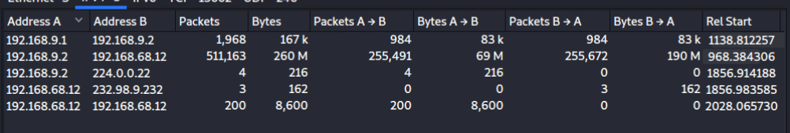
Ip connections during the authenticated scan
- Run a non-credentialed scan and a credentialed scan
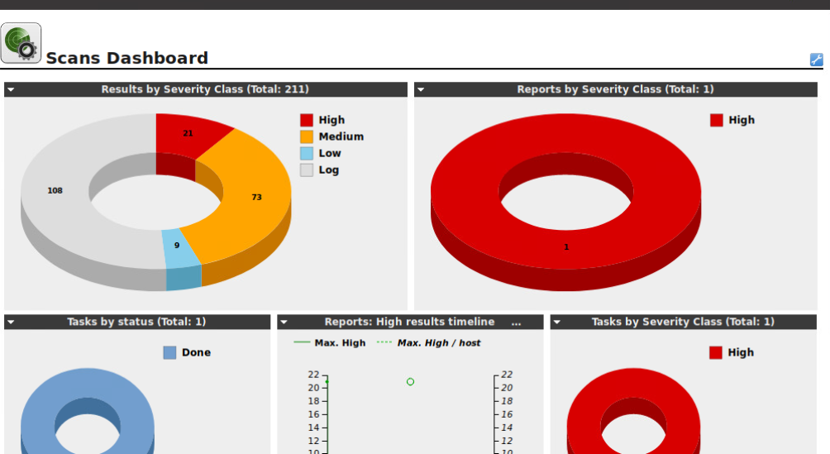
Non credentialed scan
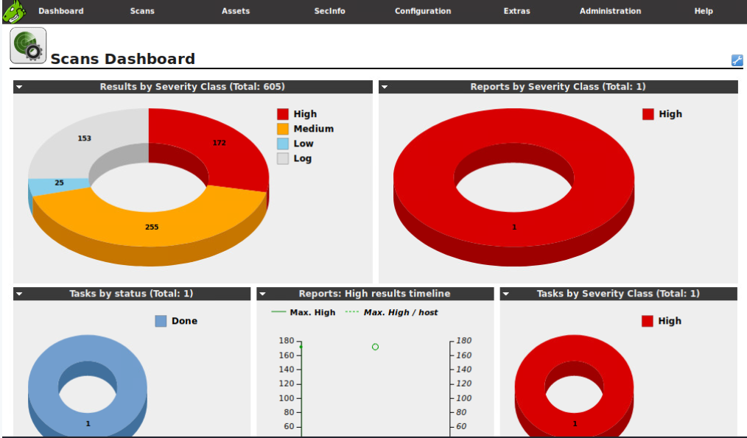
Credential scan
- How many critical findings did OpenVas discover with credentialed vs non-credentialed?
  - Non credentialed – 21 high
  - Credentialed – 172 high
- How do you fix 5 findings that were discovered (any five)?
  - Ubuntu Update for freetype USN-1403-1
    - Fix Update package sudo apt reinstall libfreetype6-dev (V1.6 update_18)
  - Oracle Java SE Multiple Vulns April 2016
    - Fix update to a newer version ideally the latest version
  - TIKI WIKI CMS Groupware End of Life Detection
    - Fix install a supported version that is not in EOL
  - Ubuntu update for bash USN-2363-1
    - Fix update packages
  - Ubuntu update for Xulrunner vulnerabilities USN-1049-1
    - Fix update packages
  - OS End of Life Detection
    - Fix run sudo apt upgrade to upgrade the os version
  - Most issues on the scan for the High priority can be resolved via a package update / installation

